School of Informatics & Cybersecurity - Assessment Submission Coversheet

Student Information
Student Number: | ******
Student Name: | Viktoriia Bielhrad

Module Information
Module Title: | Cloud Fundamentals
Module Code: | COMP H2039

Assessment Information
Assessment Title: | Designing and Implementing a Proof of  Concept Cloud Solution based on a clients  needs

Declaration
☐ I confirm that I have read and understood the University’s Academic Integrity Policy.
https://www.tudublin.ie/explore/about-the-university/academic-affairs/academic-quality-assurance-and-enhancement/academic-integrity/
☐ I have completed the TU Dublin AI Driving License theory test.
https://www.tudublin.ie/explore/about-the-university/academic-affairs/lta/lta-resources/artificial-intelligence-driving-license/
☐ I declare that this assessment submission is my own work.
☐ I confirm that I have read and understood the AI traffic light system used as part of this assessment brief and I have adhered to the level of AI usage allowed for this assessment.

Student signature:
Date: | 07/12/25

TASK 1: Proof of Concept (POC) Implementation

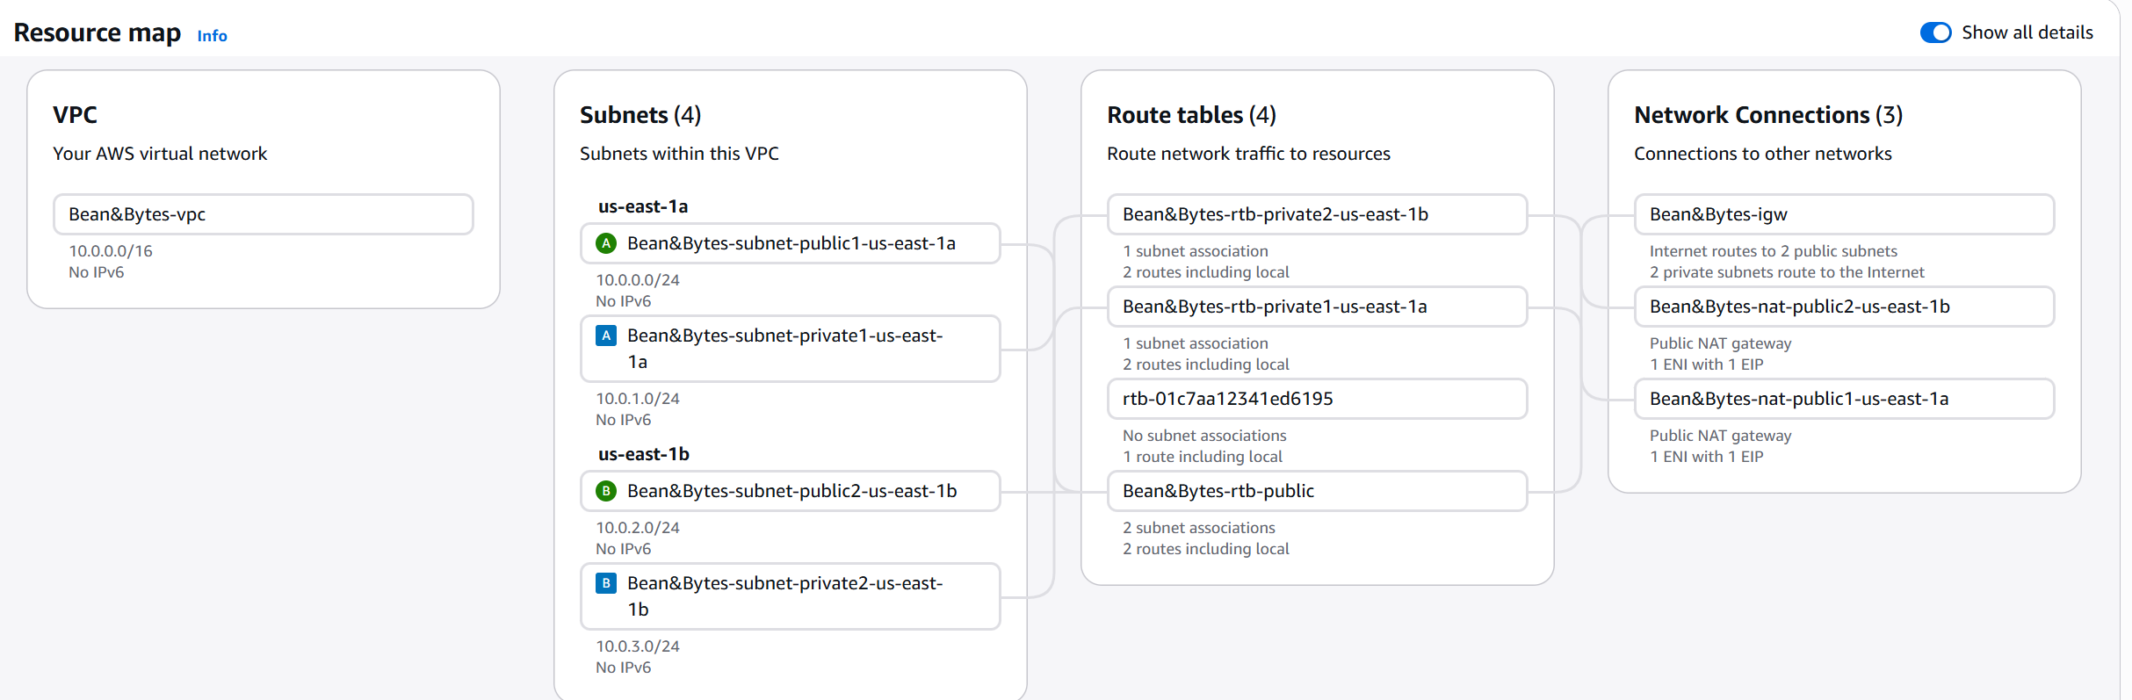
Figure 1 – VPC with two public and two private subnets

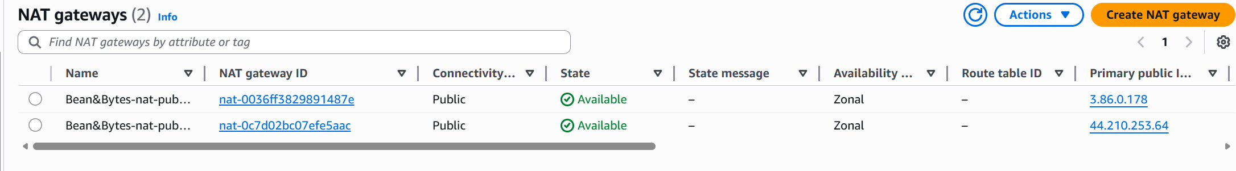
Figure 2 - two NAT Gateways in two public subnets

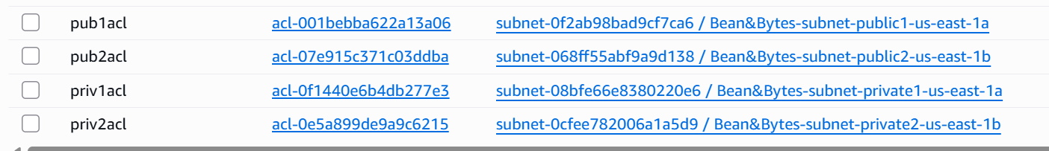
Figure 3 - Network ACLs for each subnet
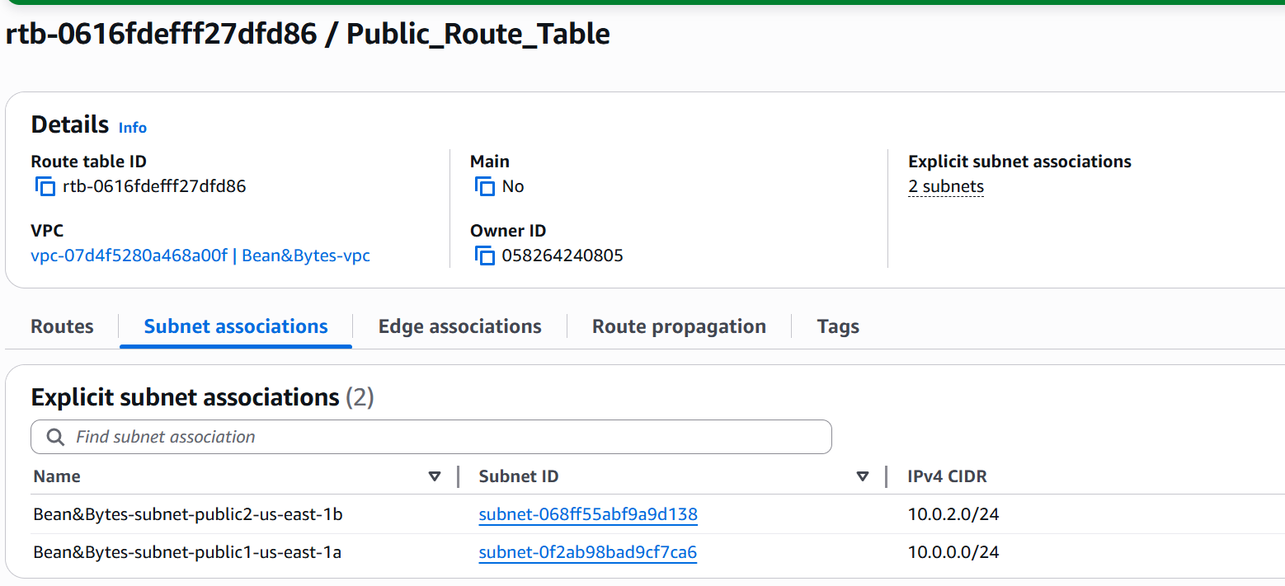
Figure 4 - Public Route Table

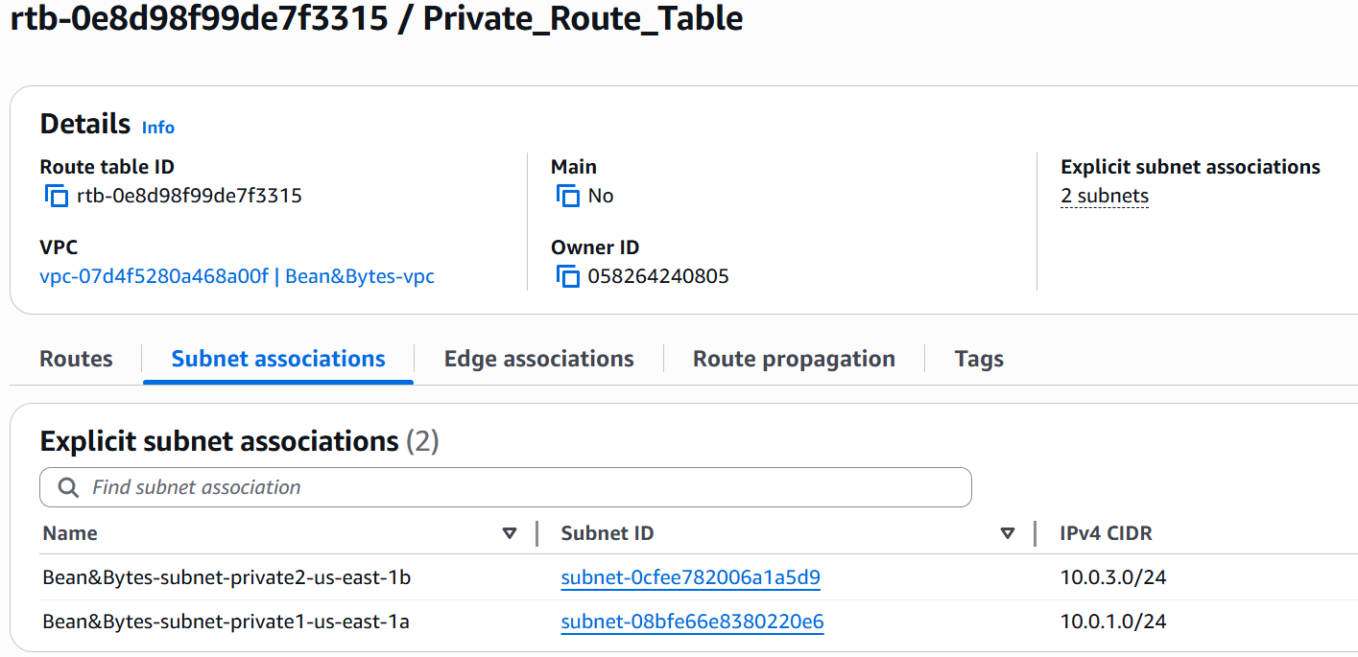
Figure 5 - Private Route Table

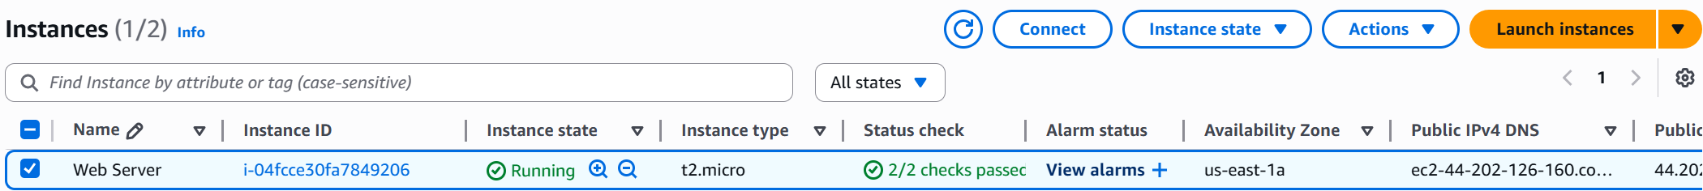
Figure 6 - Example of an instance

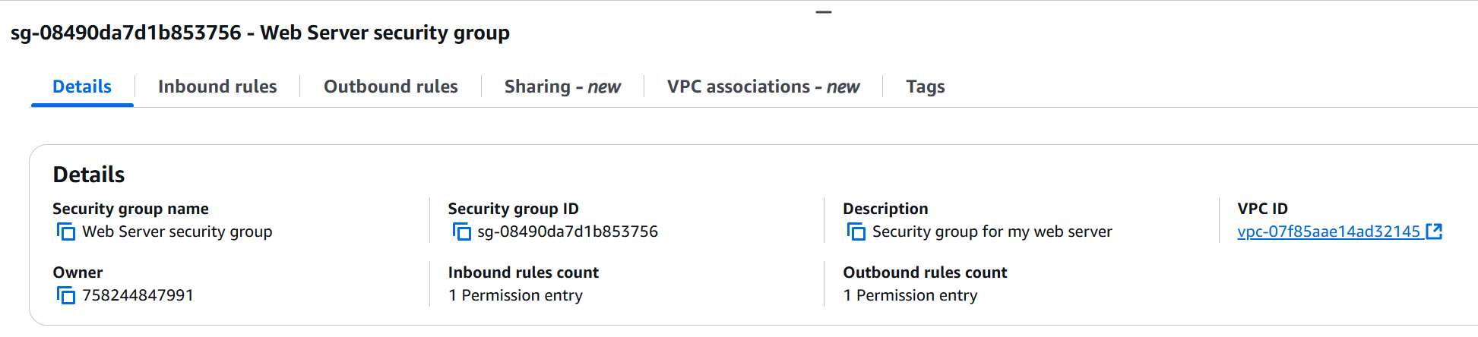
Figure 7 - Security group for EC2 instances

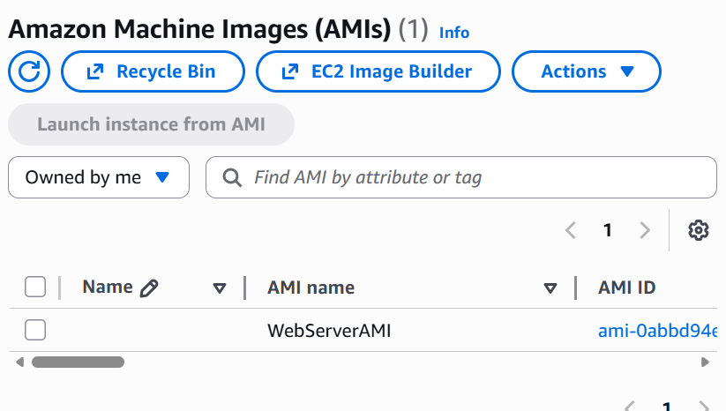
Figure 8 - AMI

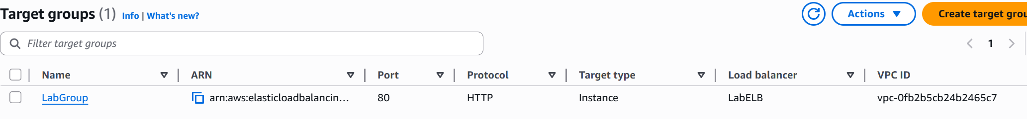
Figure 9 - Target Group example

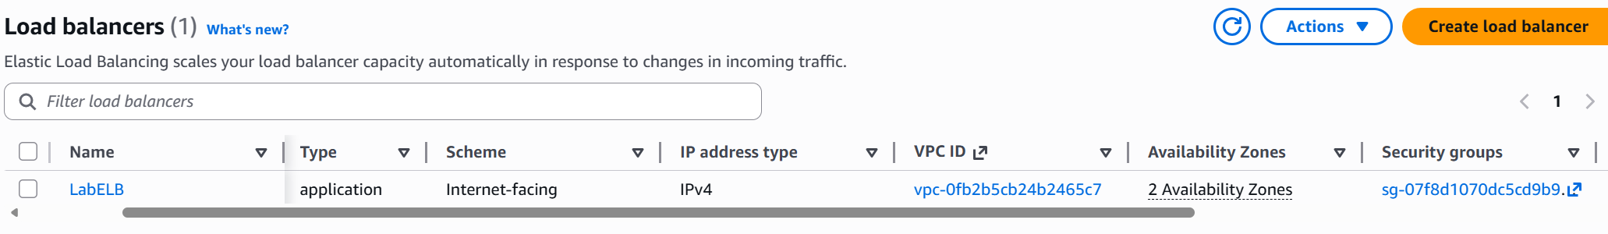
Figure 10 - Load balancer

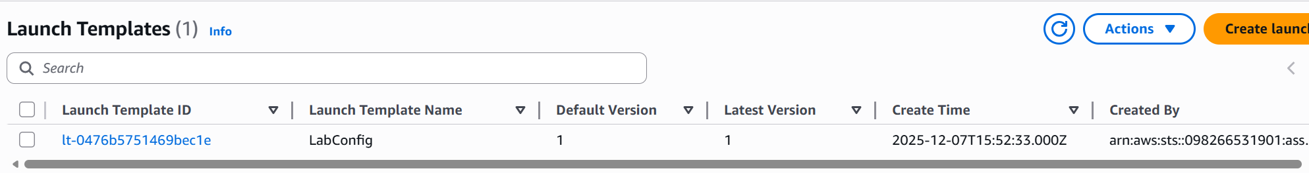
Figure 11 - Launch Template for autoscaling group

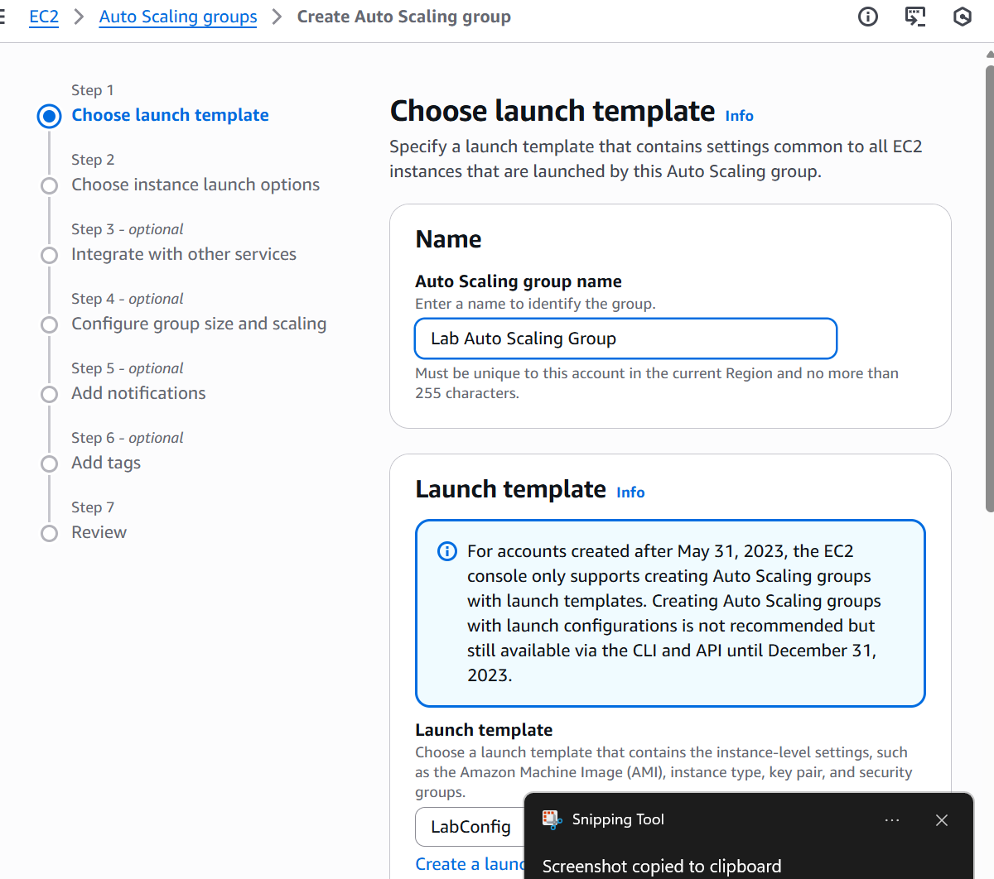
Figure 12 - Creating an autoscaling group using our template

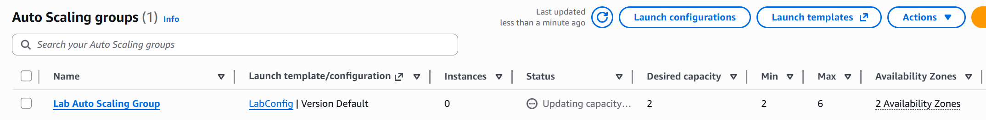
Figure 13 - Autoscaling group

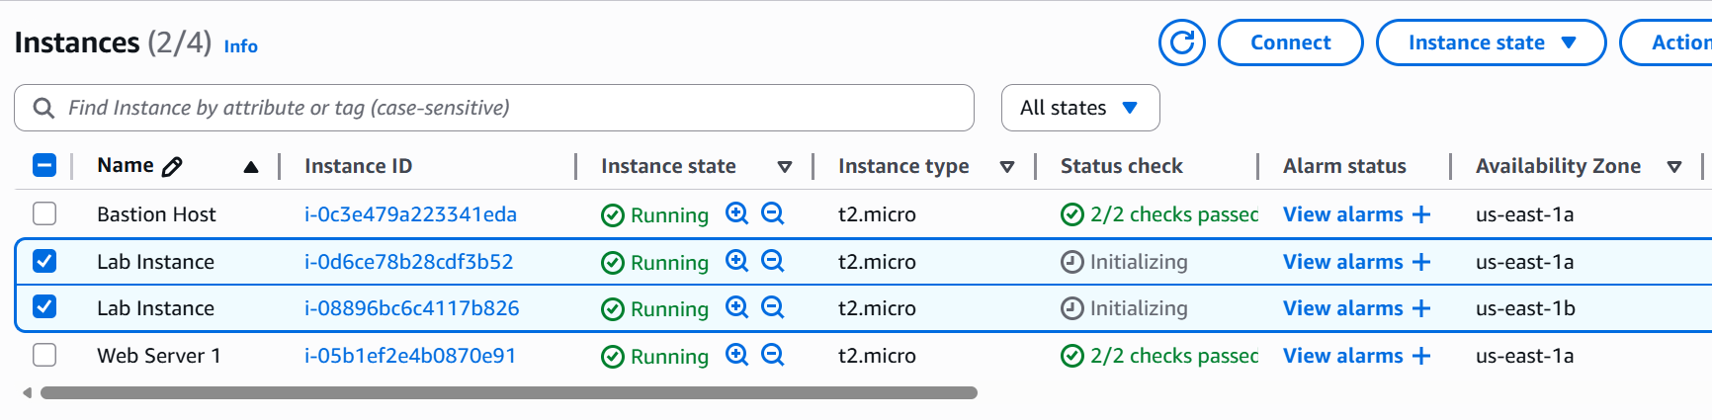
Figure 14 - Two new instances launched to reach the desired count (2 instances)

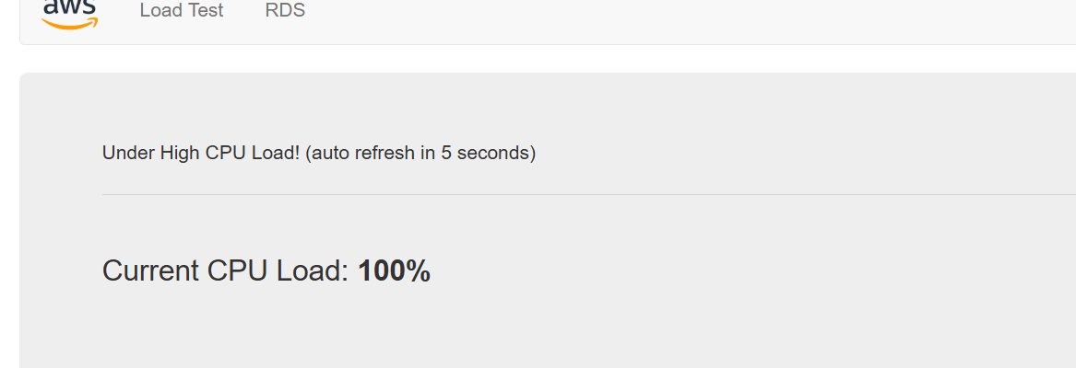
Figure 15 - Click Load Test to generate high loads (CPU Utilization > 60)

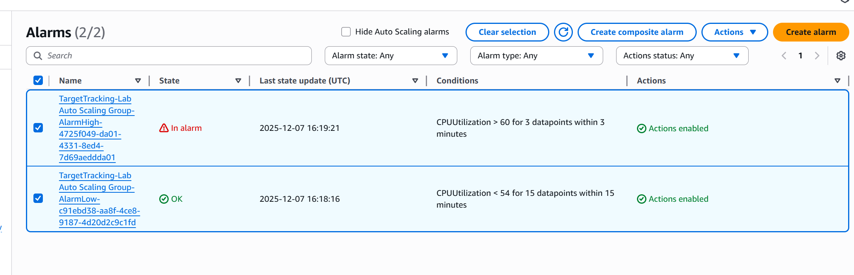
Figure 16 - CloudWatch created an alarm. In the result additional instances were launched

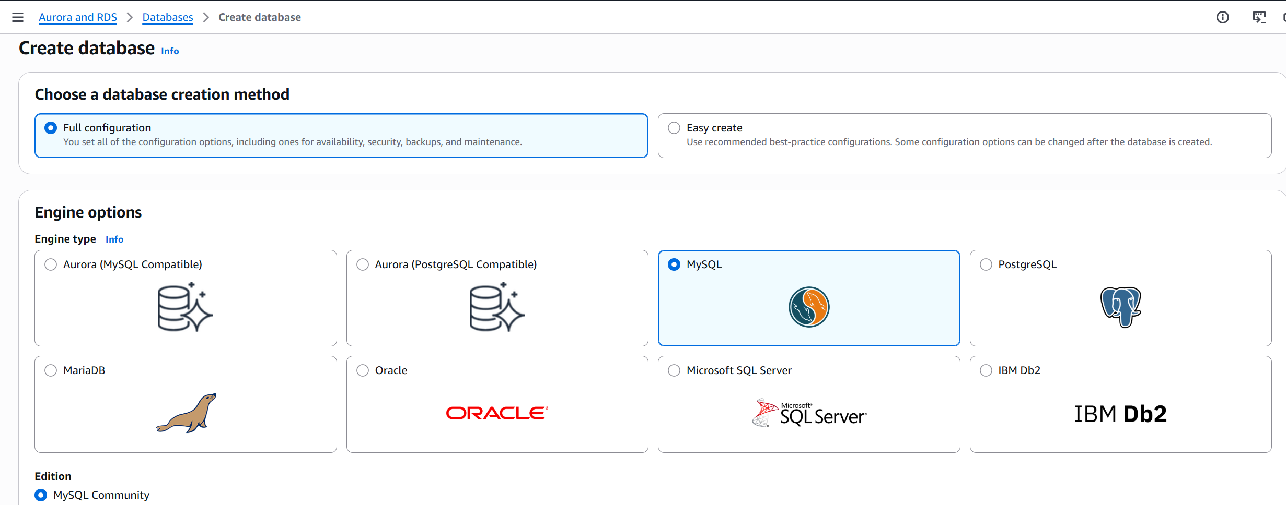
Figure 17 - Create RDS DB

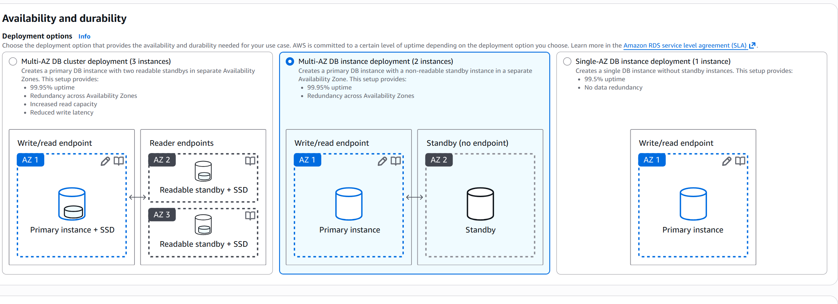
Figure 18 - Choose Multi-AZ instance deployment

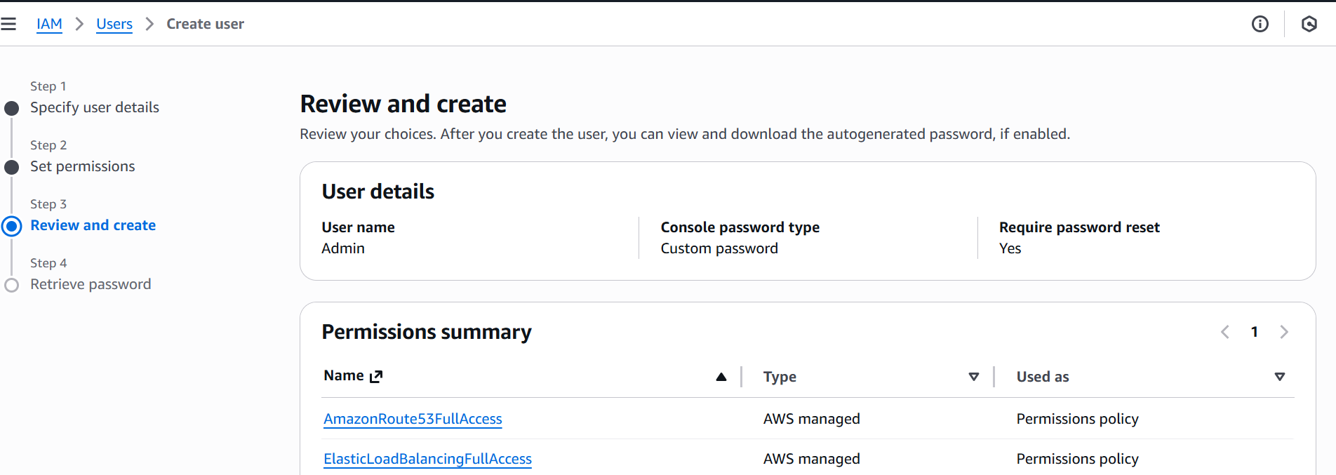
Figure 19 - Create ІАM user and give Route53/Elastic Load Balancer permissions

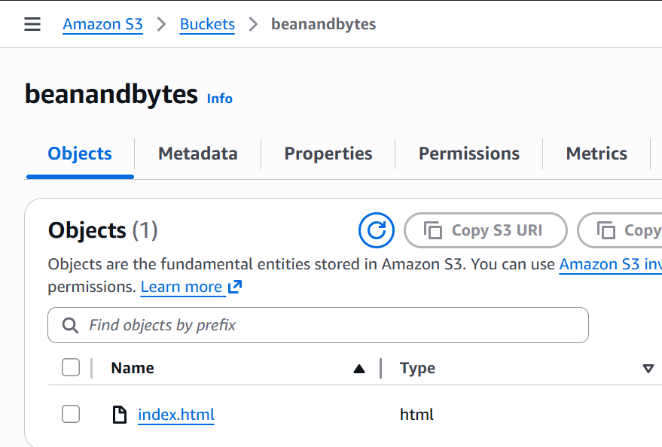
Figure 20 - Create S3 bucket hosting a static website

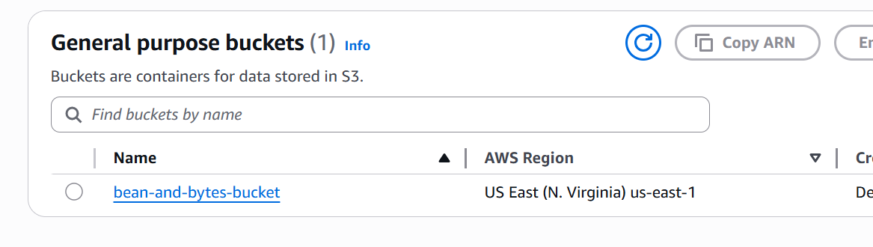
Figure 21 - Create S3 bucket

TASK 2: Create a detailed architecture AWS diagram (using draw.io) to meet ‘Bean & Bytes’ needs

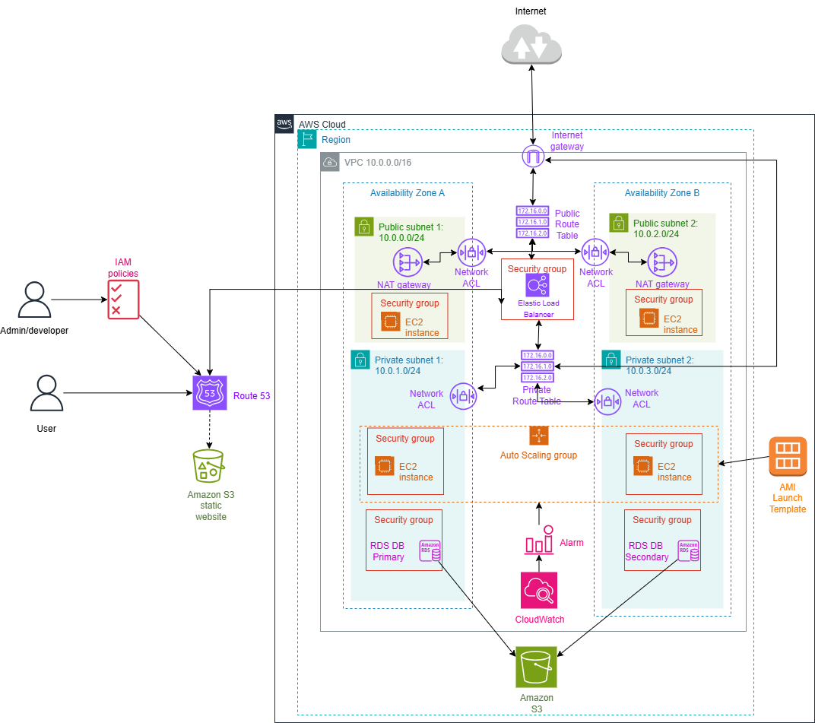
Figure 22 - architecture AWS diagram

TASK 3: Fully proposed technical solution
‘Bean & Bytes’ are a small coffee café company start-up based out of Dublin, Ireland. They have an on-premises data center and want to move all of their components to the Cloud.
Their key requirements:
- Reliable load balancer
- Automatic increase in the number of instances if necessary
- Use of EC2 compute service
- S3 bucket that will host a static website to display in case of a failure
- Use of Amazon RDS (MySQL database engine)
- Automatic backup
- High availability and security
- Control of access to services
- Internet access for updates and patches without exposing servers or databases to the Internet

First, we need to choose a region to store our cloud resources. As always, I choose North Virginia. Here I create an Amazon VPC (Figure 1) which is an isolated virtual network where Bean & Bytes will be able to create and manage resources. Here I create 2 Availability Zones and 4 subnets. This is necessary for high availability and fault tolerance. In other words, if one zone fails, the other one still works and instantly takes over the load. Also, any data and resources are automatically duplicated between zones, so we don’t have to worry about data loss anymore. Of those four subnets, there are 2 public and 2 private. Public subnets are needed for resources with open access to the Internet(Bean & Bytes website), and private ones are for internal business resources that should not be freely accessible (databases, storage).
In order for resources in the private subnet to have access to updates and patches from the Internet, NAT gateways (Figure 2) are required in each of the public subnets, i.e. 2. It is quite possible to have only one gateway in one public subnet, but if the AZ or this NAT gateway stops working, then the resources in the second AZ lose access to the Internet. For high availability and fault tolerance, it is necessary to have two NAT gateways for each private subnet, despite the additional cost of the second gateway.
To control incoming and outgoing traffic in each subnet, I suggest adding additional protection at the subnet level itself - Network AСL (Figure 3). This is a list of rules where each rule can either allow or deny traffic. IP addresses are checked and we can deny some of them. For public subnets – allow inbound and outbound traffic to load balancer, and for private – outbound traffic to NAT Gateway.
The next step is to create a Private Routе Table (Figure 5) and a Public Routе Table (Figure 4). The Public table will contain the route to the Internet for public subnets, and the Private table will contain the route to the NAT gateway so that private subnets can access the Internet while remaining secure.
Now we can create instances. Bean & Bytes want to use the EC2 compute service for this (Figure 6). Two instances, one in each public subnet, must be created. These are the ones that will serve the Bean and Bytes website and serve customers. Figure 6 shows one as an example of what this would look like in their infrastructure, but there should actually be two of them.
Next, these instances need a Security Group (Figure 7). It serves as instance-level protection and controls access to resources within subnets. Together with the Network AСL, the Security Group forms a multi-layered protection and control. For example, my security group for EC2 instances in public subnets allows HTTP and HTTPS traffic for users and SSH for developers or administrators. Security Groups are stateful, which means that we can give permission for certain incoming traffic - then the corresponding outgoing traffic is automatically allowed too. Unlike Security Groups, ACL is stateless, so we must allow both incoming and outgoing traffic separately. Security Group for RDS – allow inbound traffic from EC2, port 3306 for MySQL + no direct access to the Internet.
It is important to create an AMI - Amazon Machine Image – (Figure 8) to launch instances. AMI contains the operating system, software, and settings needed for this. I choose Amazon Linux among the provided AMIs.
The next thing we need to create is a Target Group (Figure 9). This determines where the Load Balancer will direct traffic. The figure says that the target type is instance, so it is obvious that traffic will be directed directly to the EC2 instances within this target group. The figure also shows that there is one Elastic Load Balancer (Figure 10) that is connected to this group. We can notice that in the Availability Zones line it says 2 zones, which means that the balancer distributes traffic across two zones within this region. There is also a security group for a load balancer.
Now it’s time to create a Launch Template (Figure 11) for the future Autoscaling group (Figure 12). For this, we need our previously created AMI. This template defines how a new instance will be created, i.e. what software it will have, settings, etc. It is very convenient to attach this to the autoscaling group because this way it will create and launch ready-to-use and identical EC2 instances.
The autoscaling group (Figure 13) is key to the scalability of Beans & Bytes. I want to launch 2 instances at once (Figure 14) in private subnets, so the desired capacity is 2. It is also the minimum capacity to maintain stable operation of the web server. The maximum capacity shows the required capacity during peak times, it is also shown that anautoscaling group is spread over two zones, which provides reliability.
For autoscaling to really work, we need to enable CloudWatch. It creates an Alarm (Figure 16) that launches new instances if the CPU load is above 60% (Figure 15).
Next, Bean & Bytes needed an Amazon RDS database(Figure 17). They complained that they were constantly running out of disk space, so Amazon RDS uses the MySQL engine, which is fully scalable, creates automatic backups, and is available in two zones (Figure 18). This means that Bean & Bytes can have a primary database in the first zone and a secondary database in the second, where the information from the primary database is constantly replicated to the secondary, they are identical. Why would they need databases in two zones? If one zone fails, the other, identical, is still running and can do the same job. This provides redundancy and availability.
In Figure 22, we can see that when a user want to order something from Bean & Bytes, they enters something like binandbytes.com and Route53 (a DNS service) directs them to the Load Balancer. The Load Balancer receives traffic and distributes it between instances. The Load Balancer first checks the target group and which instances are Healthy, that is, working. The instances of the autoscaling group work with the databases while processing the request and then give the answer to the user.
Users have access to the Bean & Bytes website while the admin or developer needs to have access to Route53/balancer or other resources for patch, updates or fixes in case of a crash. Then it would be wise to give these or those people appropriate permissions according to their role and not forget authentication of course. This is all possible with IAM policies (Figure 19).
A very important thing is to have a S3 bucket for storing various files and backups (Figure 21) and a static website (Figure 20) which will be useful, for example, in the event of a Load Balancer failure, then Route53 will redirect the user to a static web page with a message like "Sorry, a technical error has occurred. Our engineers are already working on fixing it. Please try again later."

TASK 4: Sustainability and Cost optimization

Good practices for cloud sustainability that I have implemented in my solution:
- Autoscaling group with CloudWatch - maximum utilization and minimum energy consumption.
- Using RDS and S3 - backup and replication of data occurs automatically, which is more efficient than manually. Moving data that we use infrequently to storage.
- Many AZs - load distribution between two zones, less risk of downtime.
- Multi-layered security (Security groups and ACLs) - reliable protection against resource consumption on malicious traffic
- Launch template - make sure that all instances are the same, which provides stability

Sustainability advices for ‘Bean & Bytes’ as an improvement process for the future:
- Choose another region if possible - sustainability guidance suggests considering regions with lower carbon intensity of electricity supply
- Using AWS Trusted Advisor - analyzes cost optimization, performance, security, fault tolerance, service limits - from there there are several points closely related to sustainability and these are:
1) optimization of the instances - the advisor will let us know if there are unnecessary instances, for example, which can be removed and thus consume less energy
2) performance - where to improve the configuration for better resource utilization.
3) service limits - avoid too large scales
in general, this service is about helping with optimization, which is the key to improving sustainability.

Current Cost Optimization (my solution) = 6-9000 euro per year - EC2, RDS, NAT Gateways, Load Balancer, Route 53, S3…
How ‘Bean & Bytes’ can scale this cloud service effectively in a cost optimized fashion:
- Switch to reserved instances if they know in which periods they will have higher load.
- Move old backups to C3 Glacier which is cheaper.
- CloudFront - can reduce the load on the load balancer by delivering the response to the user request from the nearest edge location, this is also less latency
- Now if we add the sustainability practices and cost optimization improvement practices above, we get approximately 3-3500 euro per year on average or 4500-6000 under heavy load.

References:
- Using identity-based policies (IAM policies) for Amazon Route 53 - Amazon Route 53. (n.d.). https://docs.amazonaws.cn/en_us/Route53/latest/DeveloperGuide/access-control-managing-permissions.html
- Long-term backup options for Amazon RDS and Amazon Aurora | Amazon Web Services. (2025, March 7). Amazon Web Services. https://aws.amazon.com/blogs/database/long-term-backup-options-for-amazon-rds-and-amazon-aurora/
- Sustainability Pillar - AWS Well-Architected Framework - Sustainability Pillar. (n.d.). https://docs.aws.amazon.com/wellarchitected/latest/sustainability-pillar/sustainability-pillar
- Free Cloud computing services - AWS free tier. (n.d.). Amazon Web Services, Inc. https://aws.amazon.com/free/?trk=565b5691-9a9f-47e5-aa27-c65545b71912&sc_channel=ps&s_kwcid=AL!4422!10!71399808875074!!!!71400358490134!!486362158!1142394360117525&ef_id=aec57b36bdea1d7227401200ada19994:G:s&msclkid=aec57b36bdea1d7227401200ada19994

